SON 1
Woodlands Road

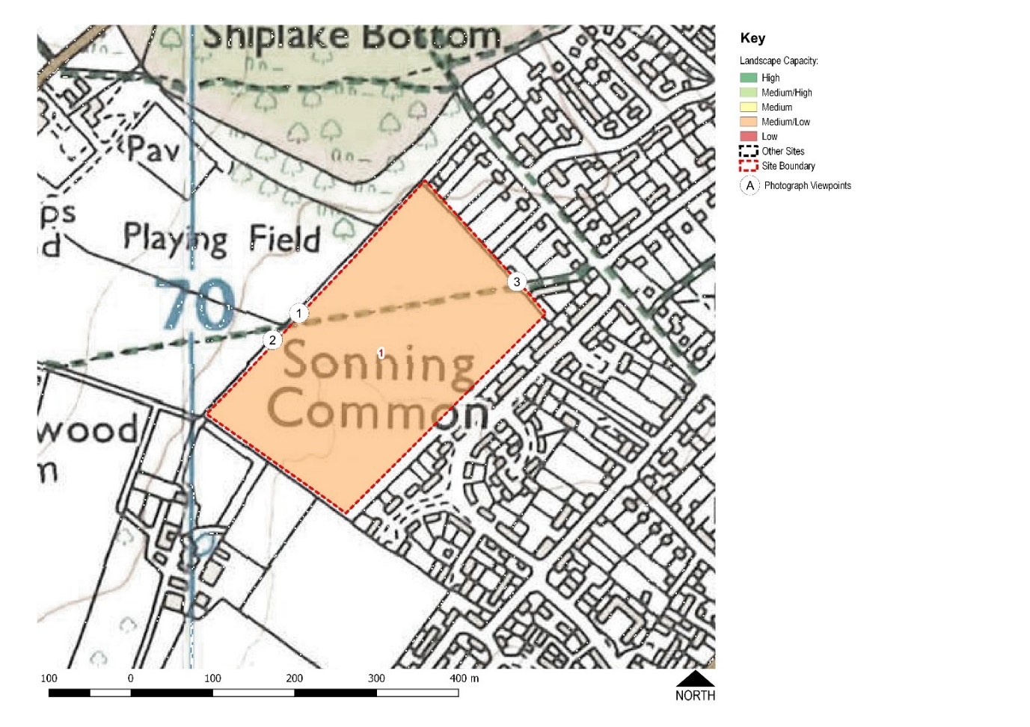
- The 6.2 hectare SON 1 site is adjacent to the Old Copse ancient woodland and abuts the gardens of Woodlands Road, Orchard Avenue and Lambourne Road.

- There is no vehicle access from a public road.

- It is currently agricultural land within the AONB and designated as Local Green Space (LGS) within the existing Neighbourhood Plan.

The independent consultant recommends that SON 1 is not considered as a potential site for development due to the following constraints:

- Development on this site could harm public views from the wider AONB to the west
- It would harm the setting of the Public Right of Way
- It would result in the loss of a valued Local Green Space
- It would harm the landscape and visual setting of the AONB
- The only existing access to the site is along the Public Right of Way
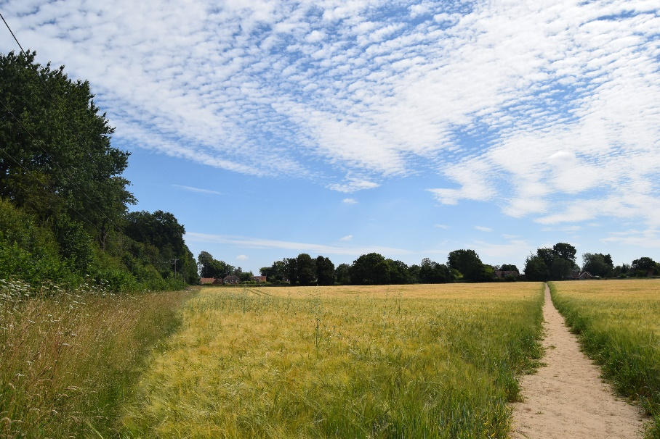

NOT RECOMMENDED FOR DEVELOPMENT
SON 12a
Blackmore Lane North (lower)

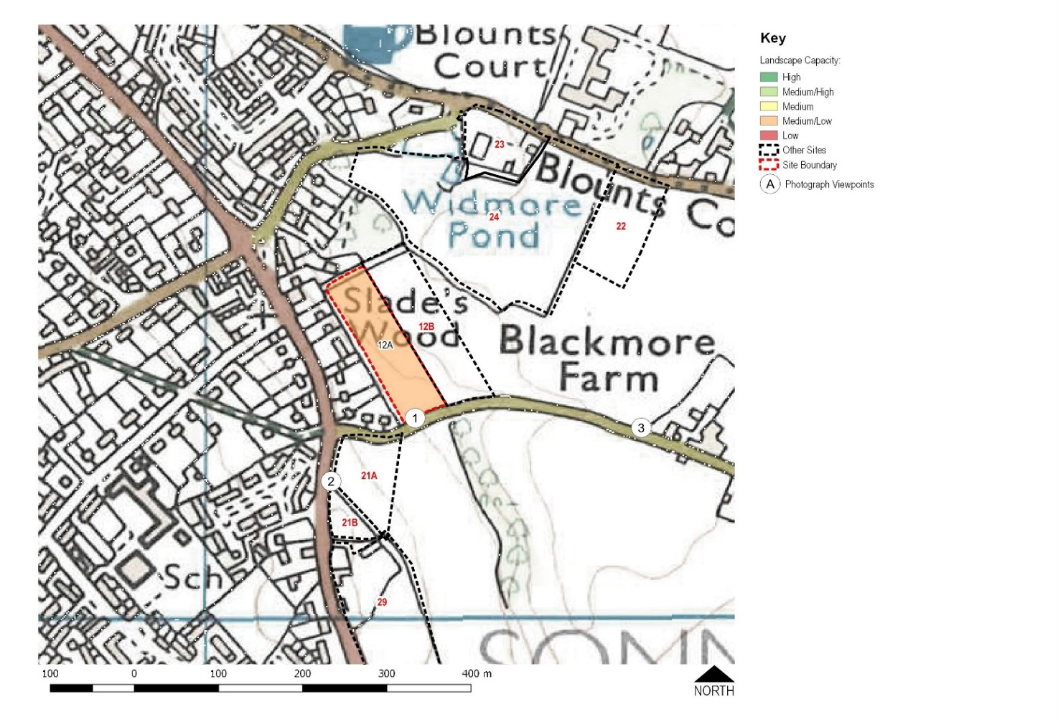

- The 0.9 hectare SON 12a site is agricultural land located within the AONB alongside Blackmore Lane.

- Access is from Blackmore Lane or through adjacent undeveloped sites.

The independent consultant recommends that SON 12a is not considered further as a potential site for development due to the following constraints:
- Negative effect on the settlement pattern
- The site’s location within the AONB
- The generally rural and tranquil nature of the setting

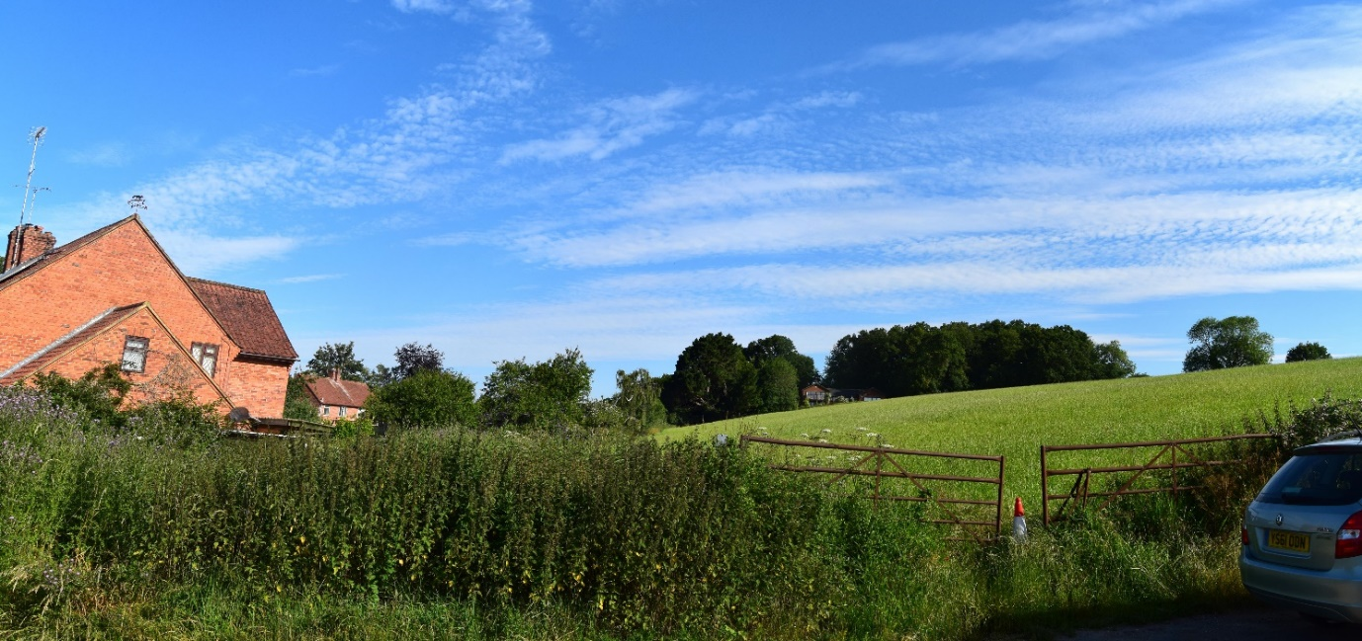

NOT RECOMMENDED FOR DEVELOPMENT

SON 12b
Blackmore Lane North (upper)

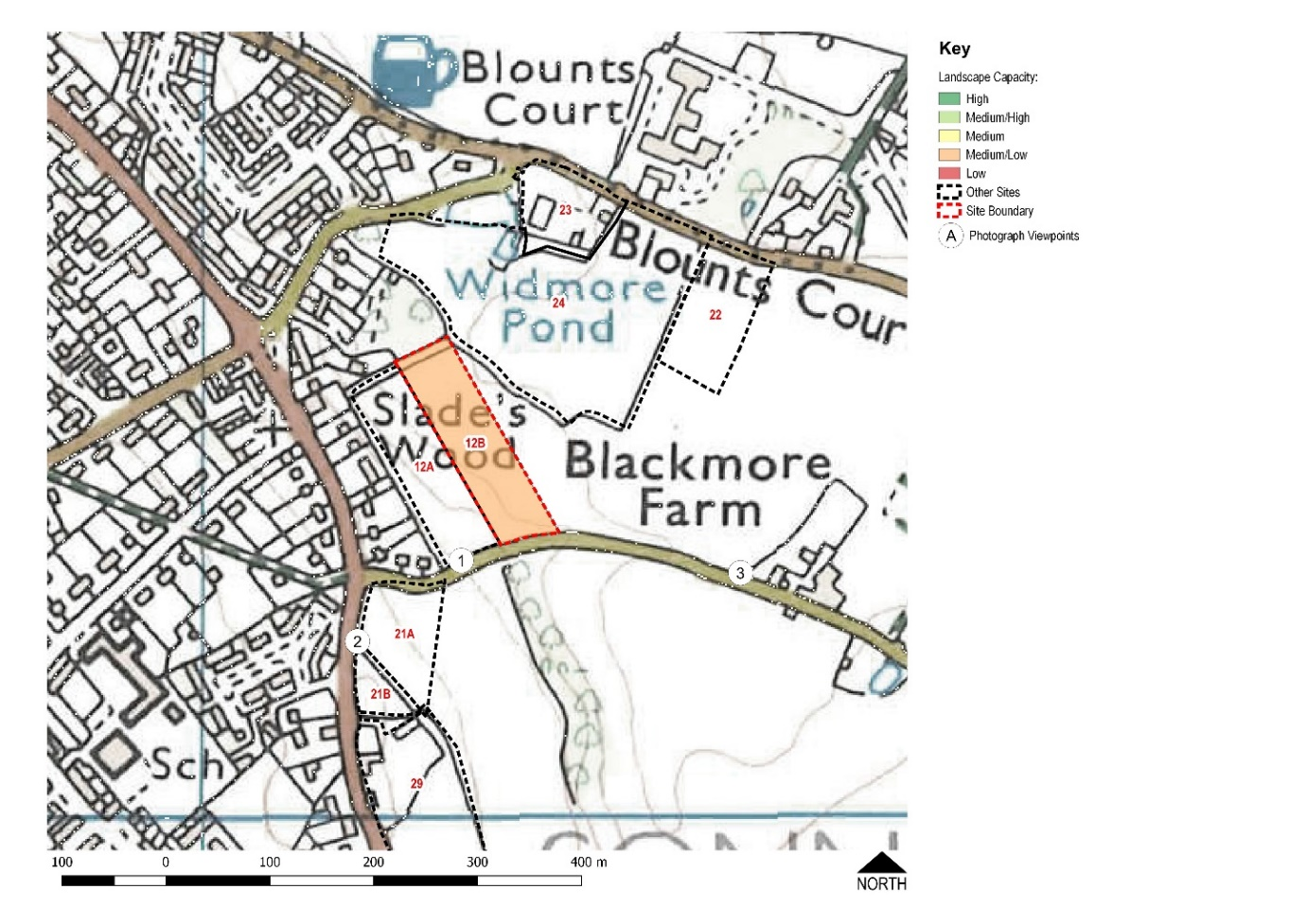
- The 1.3 hectare SON 12b site is agricultural land within the AONB.

- Access would be from Blackmore Lane, probably via SON 12a.

The independent consultant recommends that SON 12b is not considered further as a potential site for development due to the following constraints:

- Negative effect on the settlement pattern
- The site’s location within the AONB and the potential harm to its special qualities
- The generally rural and tranquil nature of the setting
- Blackmore Lane, the only possible means of access, is very narrow and classed as a ‘Failed Road’.

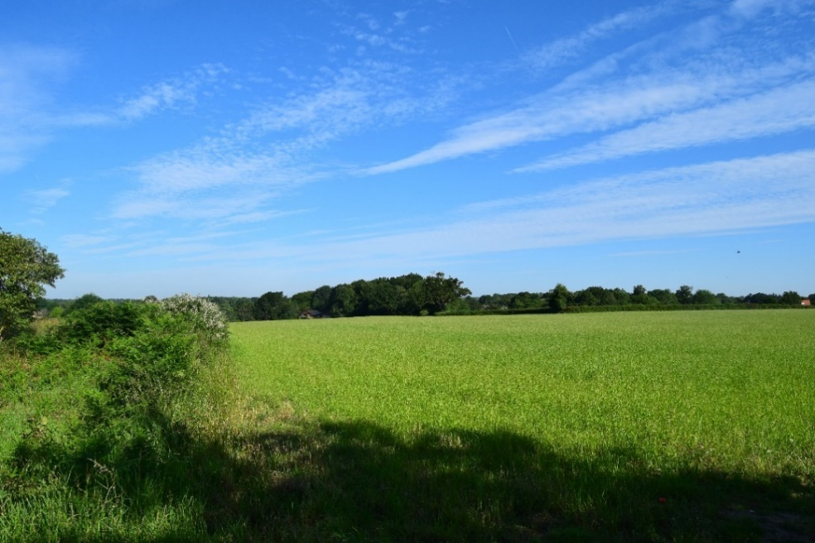

NOT RECOMMENDED FOR DEVELOPMENT
SON 21a
Blackmore Lane South

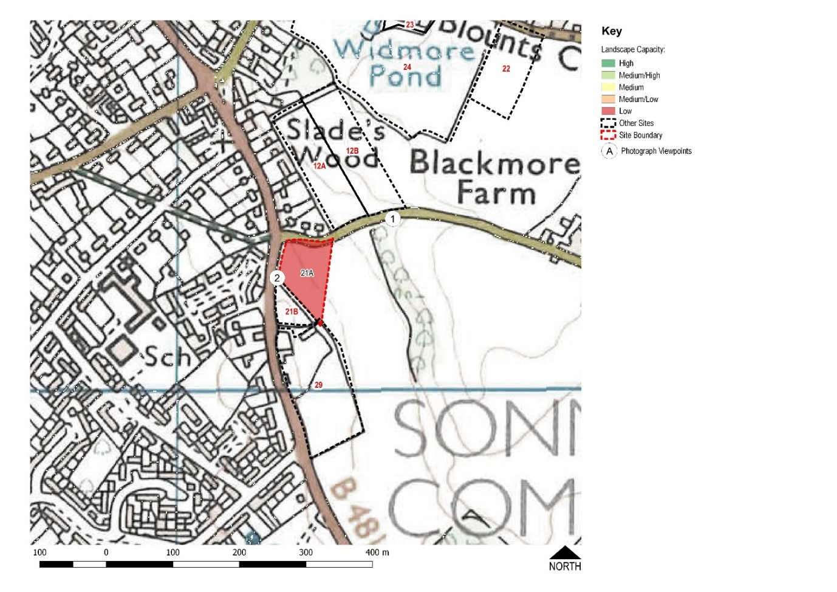
- The 0.7 hectare SON 21a site is agricultural land within the AONB.

- Access is from Blackmore Lane or Peppard Road.

The independent consultant recommends that SON 21a is not considered further as a potential site for development due to the following constraints:

- The negative effect on the settlement pattern and the strong countryside edge formed by the Peppard Road
- The visual prominence of the site
- The site’s location within the AONB and the potential harm to its special qualities
- The generally rural and tranquil nature of the setting

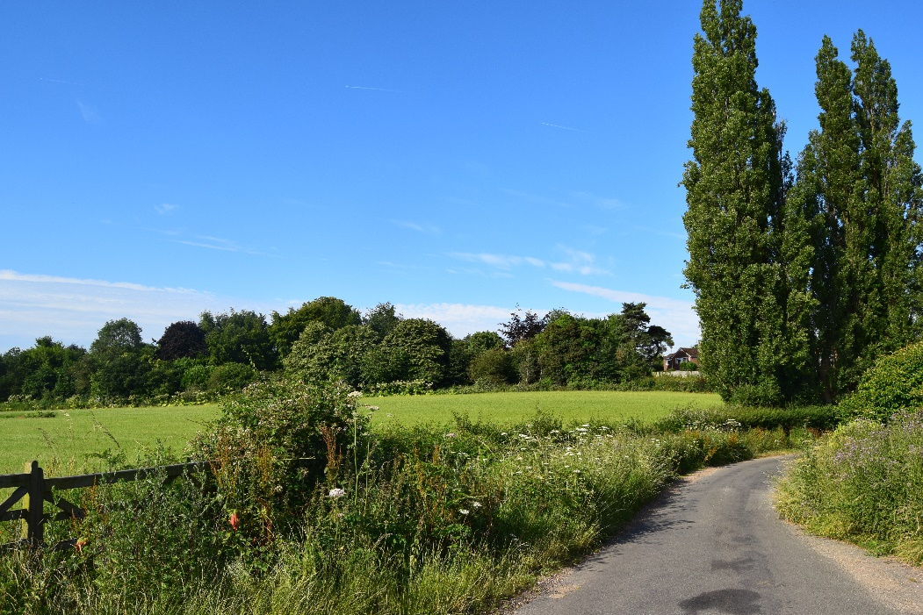
NOT RECOMMENDED FOR DEVELOPMENT
SON 21b
Land north of Reddish Manor

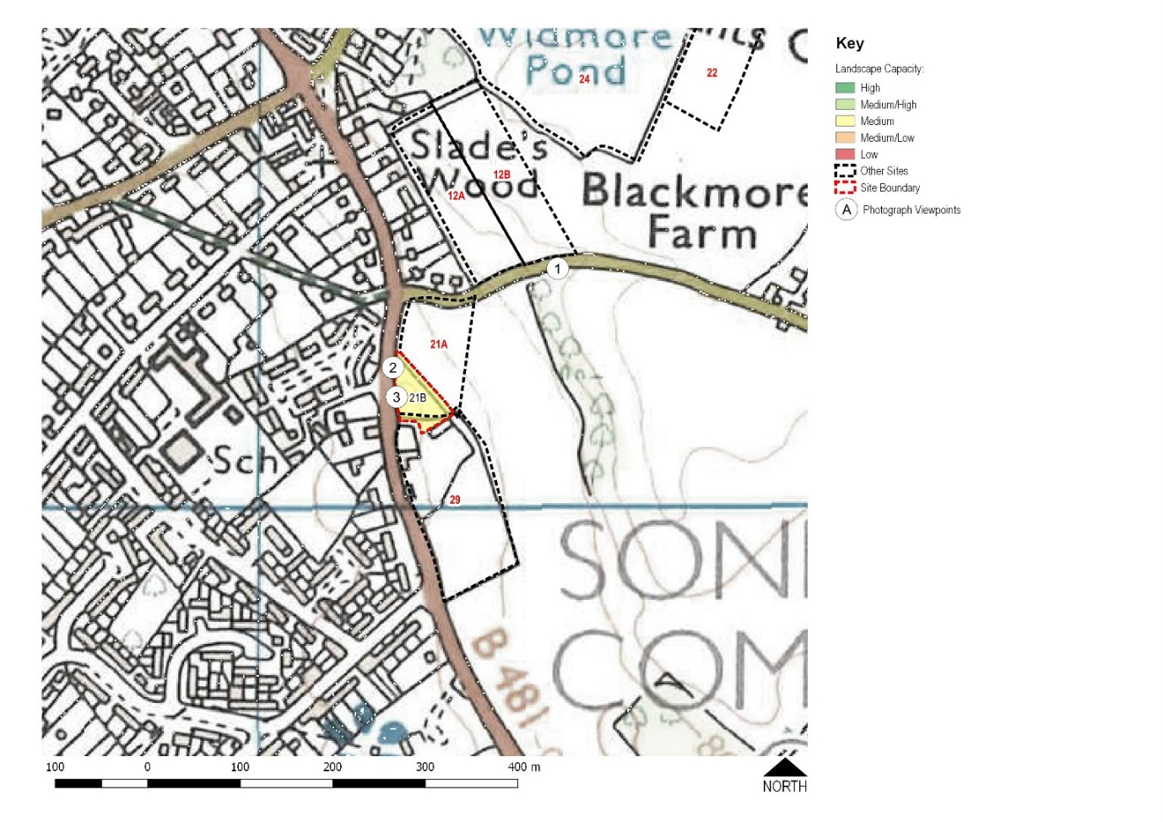
- The 0.3 hectare SON 21b site is undeveloped land adjacent to the AONB.

- Access is from Peppard Road, the B481.

The independent consultant states that the capacity of SON 21b is constrained by:

- The negative effect on the settlement pattern through the intensification of housing on the eastern side of Peppard Road
- The visual prominence of the site’s external trees
- The site’s location adjacent to the AONB
It should be considered only for very limited development

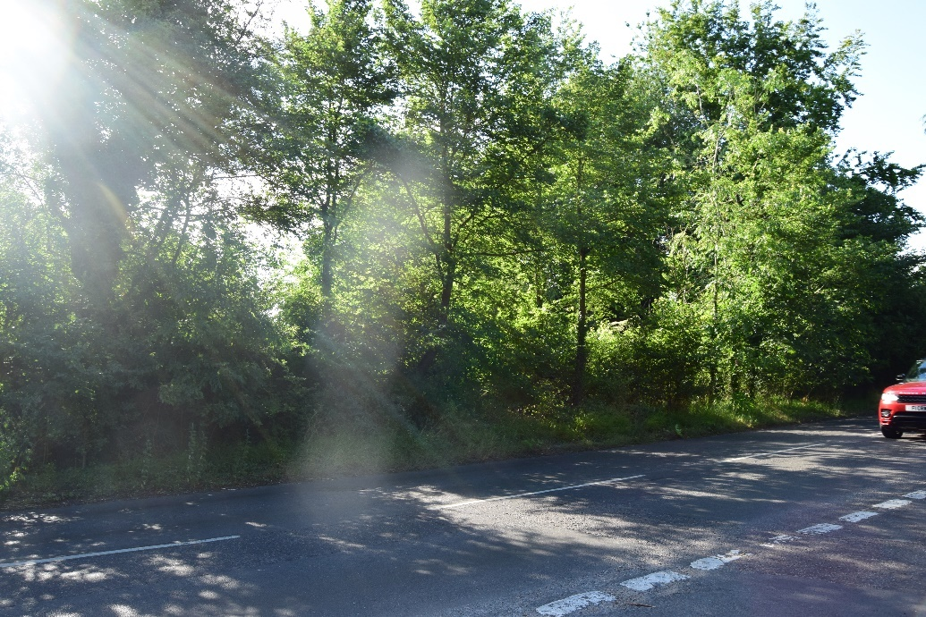

NOT RECOMMENDED FOR DEVELOPMENT

SON 22
Blounts Court Road

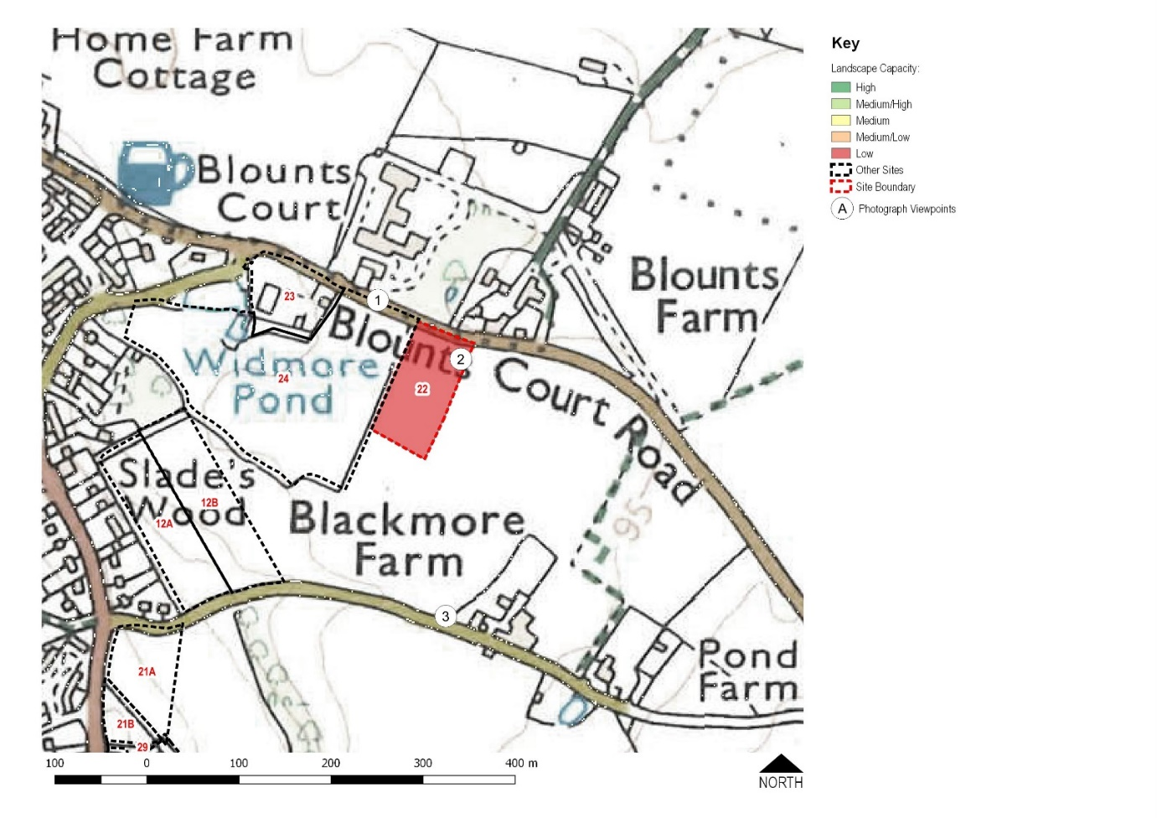
- The 0.9 hectare SON 22 site is agricultural land within the AONB.

- Access is from Blounts Court Road.

The independent consultant recommends that SON 22 is not considered further as a potential site for development due to the following constraints:

- The site’s separation from the settlement and its importance as part of the rural approach to the village
- Strong relationship with the wider countryside – development on the site would encroach into the wider landscape
- Location within the AONB and the potential harm to its special qualities
- The strongly rural and tranquil nature of the site
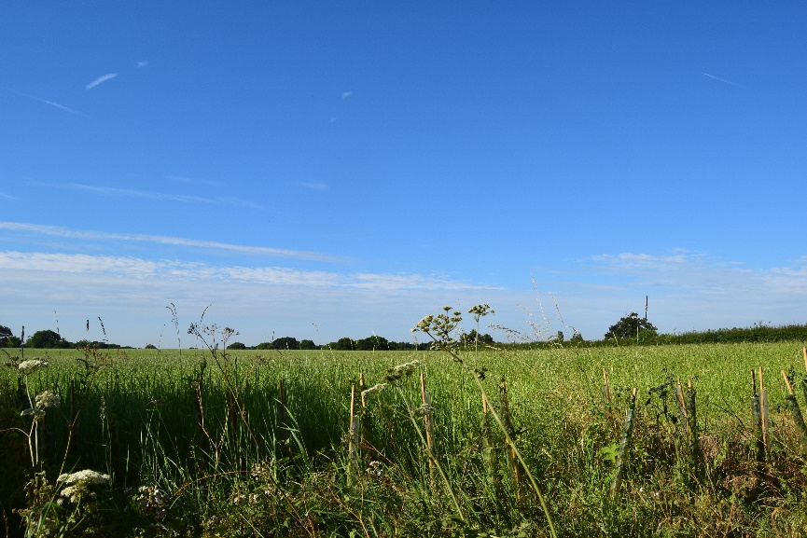

NOT RECOMMENDED FOR DEVELOPMENT
SON 23
Johnson Matthey car park

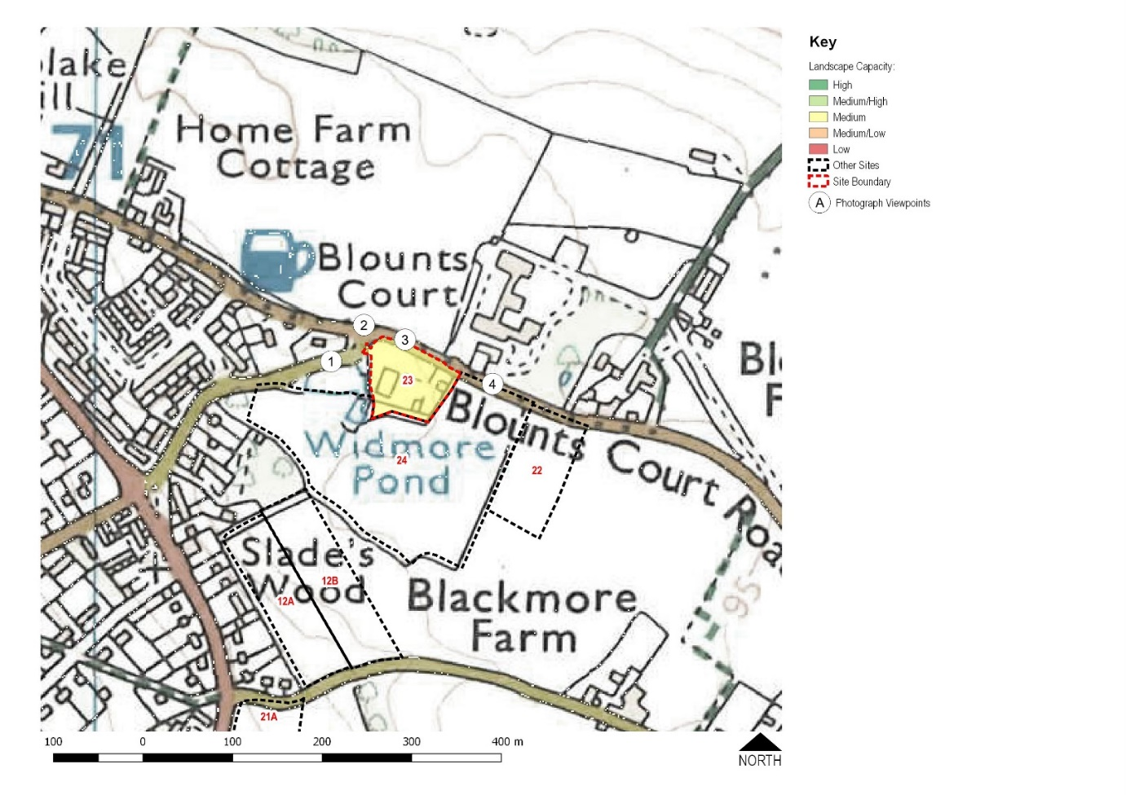

- The 0.7 hectare SON 23 site is within the AONB and is currently used as a car park by Johnson Matthey.

- Access is from Widmore Lane.

The independent consultant states that the capacity of SON 23 is constrained by:

- The site’s location within the AONB
- The visual prominence of the site from adjacent roads
- However, with a medium capacity of suitable housing, SON 23 could be considered as a potential site for further development

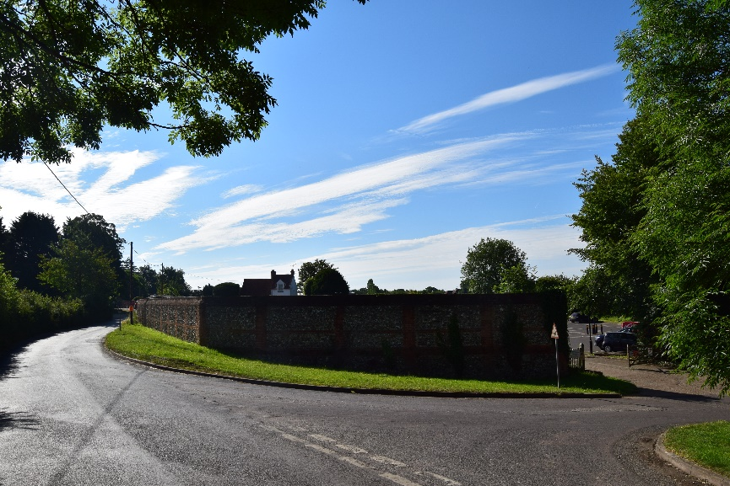

RECOMMENDED AS SUITABLE FOR HOUSING DEVELOPMENT

SON 24
Land behind Widmore Pond

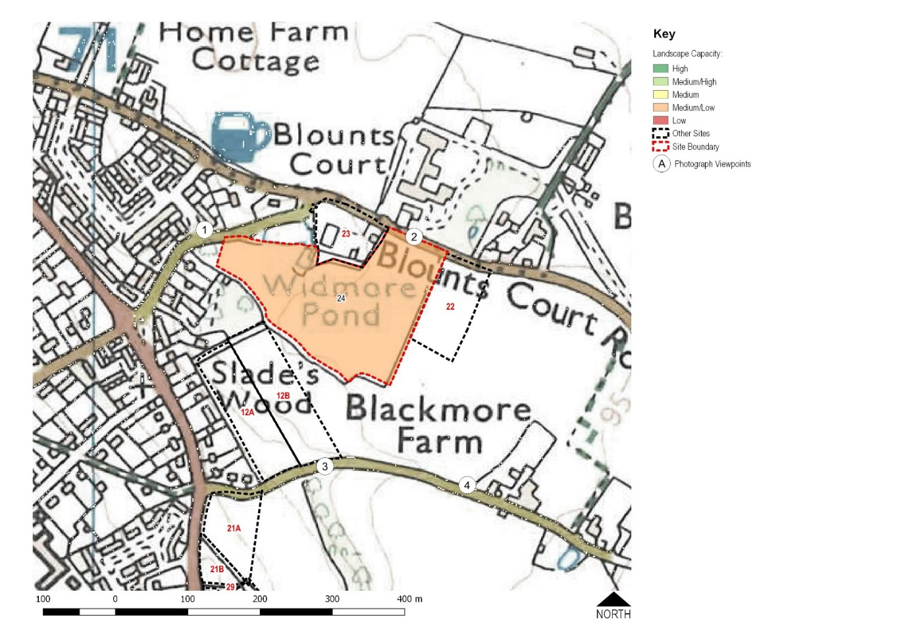

- The 3.4 hectare SON 24 site is within the AONB and is currently in agricultural use.

- Access is from Blounts Court Road.

The independent consultant recommends that SON 24 is not considered further as a potential site for development due to the following constraints:

- The site’s location within the AONB and the potential harm to its special qualities
- The visibility of the eastern parts of site from public views from within the AONB
- The importance of mature trees along the site’s western boundaries
- The remoteness of the eastern parts of the site from the settlement and the role that part of site plays in the rural approach to the village

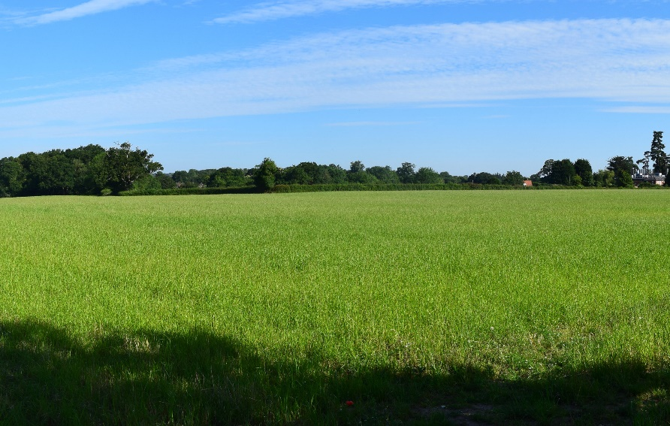

NOT RECOMMENDED FOR DEVELOPMENT

SON 26
Rudgings Plantation
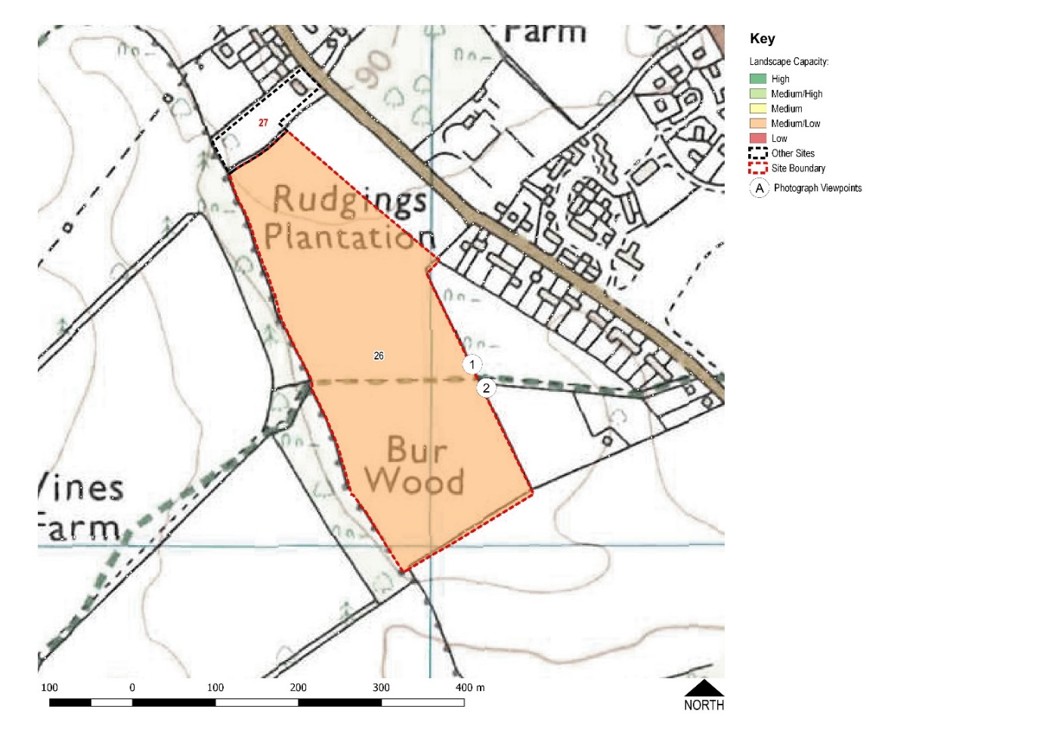
- The 6.7 hectare SON 26 site is agricultural land adjacent to the AONB.
- Access would be from Kennylands Road.
- A previous application for development on part of the site was rejected by HM Inspectorate of Planning on appeal.

The independent consultant recommends that SON 26 is not considered as a potential site for development due to the following constraints:
- Impacts on open views from, and the rural setting of, the public footpath which crosses the site
- Location within the AONB setting and the potential harm to its special qualities
- The site’s separation from the settlement and its importance as part of the rural setting of the village and its strong relationship with the wider countryside
- Development of even a small part of this site would result in the loss of the pattern of narrow, linear settlement south-west of Kennylands Road
- The strongly rural and tranquil nature of the site

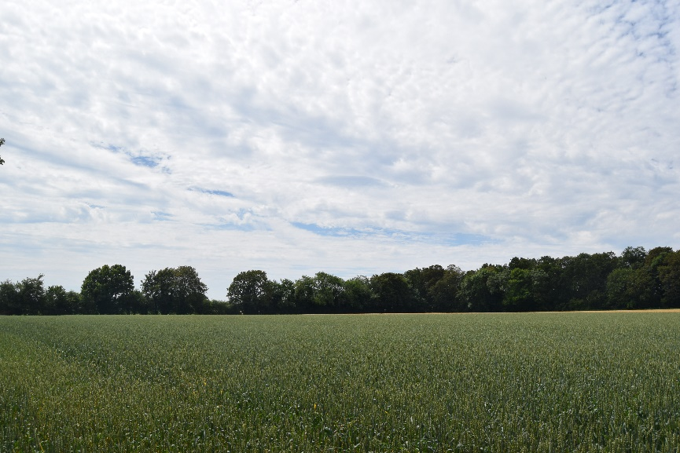
NOT RECOMMENDED FOR DEVELOPMENT
SON 27
Alpen Rose

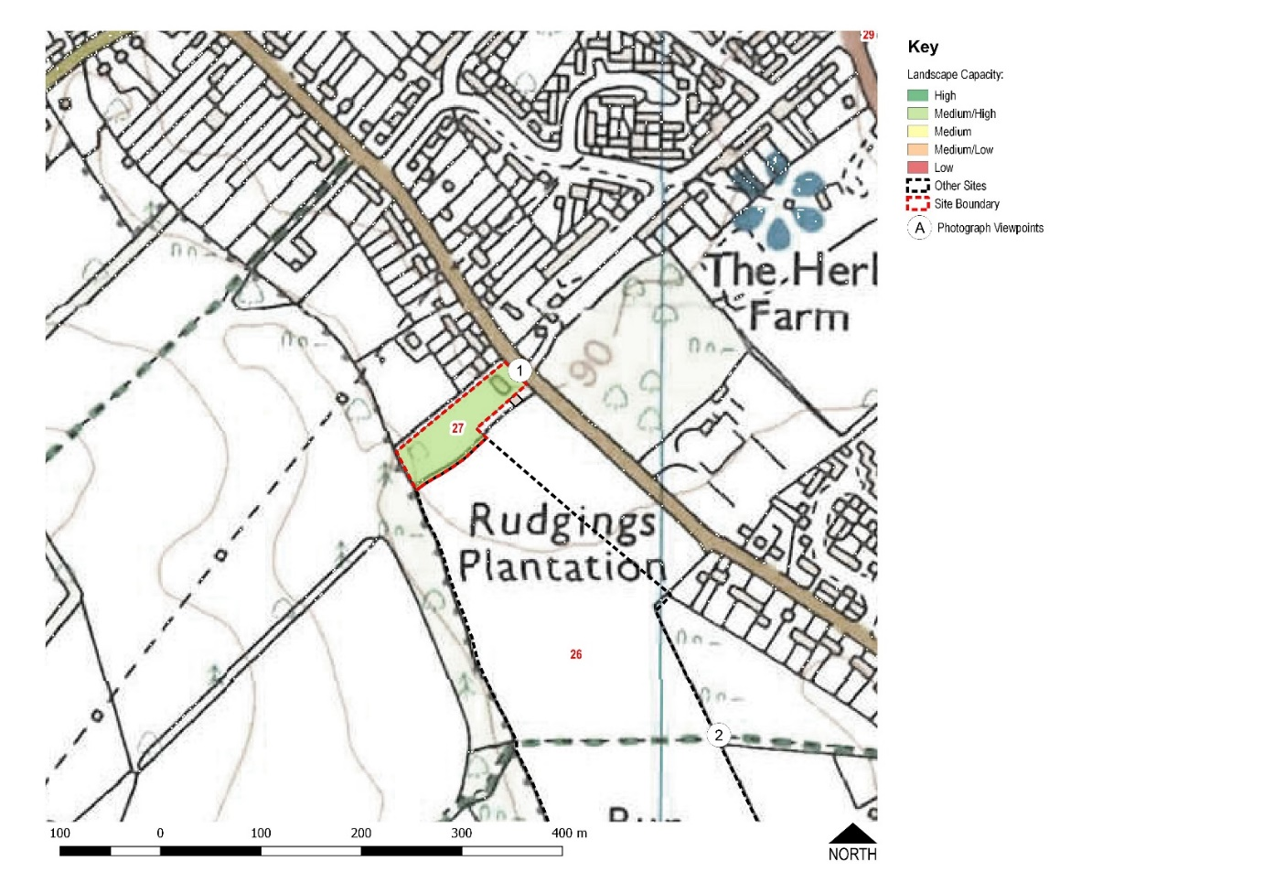

- The 0.6 hectare SON 27 site is currently a private house and garden with an orchard at the rear.

- Access is from Kennylands Road.

- There are Tree Protection Orders (TPOs) in force on the mature trees in the garden.

The independent consultant states that the capacity of SON 27 is constrained by:

- Location within the setting of the AONB and the potential harm to its special qualities
- Potential effects on the linear settlement pattern in this part of the village
- However, SON 27 could be considered further as a site for development

NOT RECOMMENDED FOR DEVELOPMENT

SON 29
Reddish Manor

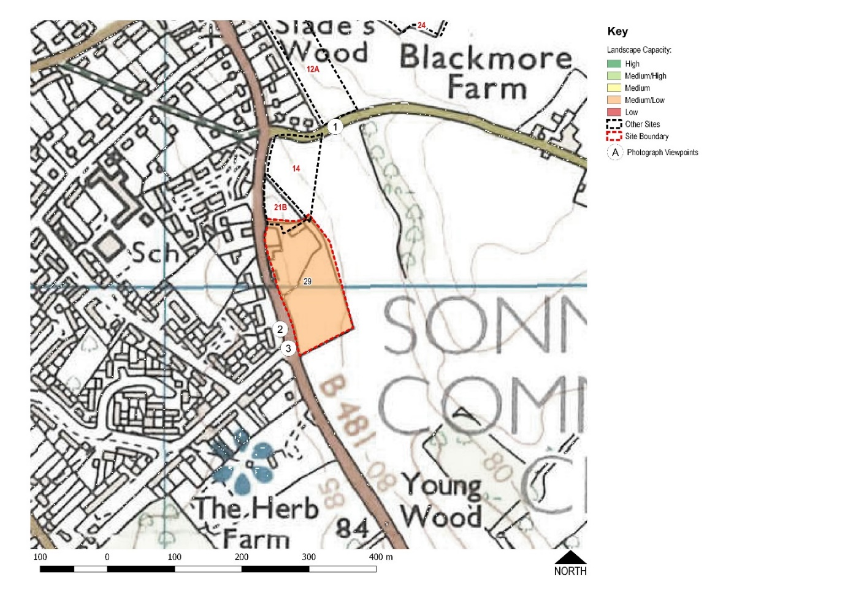
- The 1.5 hectare SON 29 site is part garden and part paddock.
- The paddock is in the AONB.
- Access is from Peppard Road (B481).

The independent consultant states that the capacity of SON 29 is constrained by:

- The negative effect on the settlement pattern through the intensification of housing on the eastern side of Peppard Road
- The visual prominence of the site’s external trees
- The site’s location within and adjacent to the AONB and the potential harm to its special qualities
- However, given that the site is well contained by its boundary vegetation and already contains a house, a very limited amount of development could be accommodated in the northern part of the site. The southern part of the site should remain undeveloped to avoid harm to the AONB and sprawl of the settlement pattern.
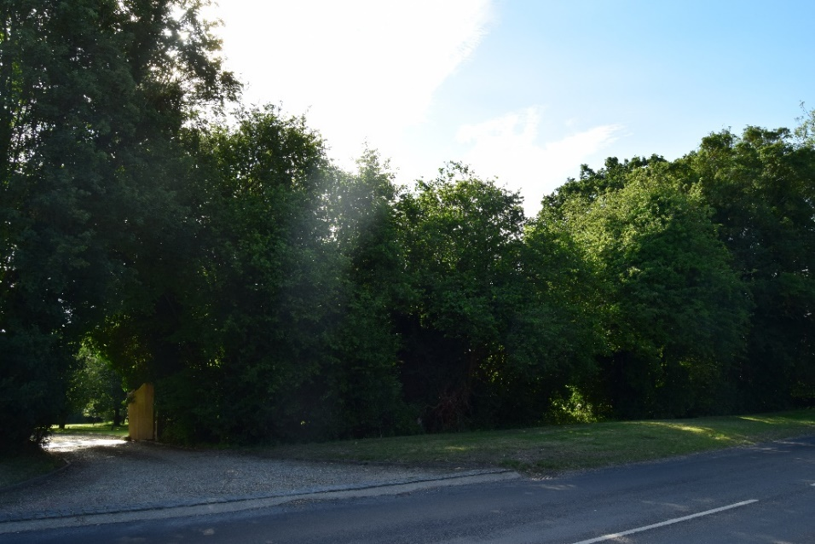
NOT RECOMMENDED FOR DEVELOPMENT
Summary of Recommendations
The following sites were put forward for development consideration by landowners:
Site Number | Location | Area | NP Working Party Recommendations
SON 1 | Behind Orchard Avenue and Woodlands Road | 6.2 ha of Local Green Space within the AONB | Not recommended for development
SON 12a | Off Blackmore Lane and behind Peppard Road houses | 0.9 ha of agricultural land within the AONB | Not recommended for development
SON 12b | Off Blackmore Lane | 1.3 ha of agricultural land within the AONB | Not recommended for development
SON 21a | Corner of Blackmore Lane and Peppard Road | 0.7 ha of agricultural land within the AONB | Not recommended for development
SON 21b | Peppard Road, opposite Red House Drive | 0.3 ha of unused land adjacent to the AONB | Not recommended for development
SON 22 | Blounts Court Road, opposite Blounts Farm | 0.9 ha of agricultural land within the AONB | Not recommended for development
SON 23 | Widmore Lane, currently Johnson Matthey car park | 0.7 ha of hard surface land within the AONB but used as a car park for decades | Recommended for 2 and 3 bedroom housing development
SON 24 | Blounts Court Road and Widmore Lane | 3.4 ha of agricultural land within the AONB | Not recommended for development
SON 26 | Kennylands Road, opposite Hagpits House | 6.7 ha of agricultural land, not in the AONB but within the AONB setting | Development restricted to 26 homes within SON 6 - already included in the existing Neighbourhood Plan
SON 27 | Alpen Rose, Kennylands Road | 0.6 ha of house, garden and orchard, within the setting of the AONB | Not recommended for development
SON 29 | Reddish Manor, Peppard Road, opposite Westleigh Drive | 1.5 ha of garden and orchard, partly within the AONB | Not recommended for development

